Solution: Extending Base Entities

In this lab, you will use the Entity Editor in Guidewire Studio to modify the TrainingApp data model.

Requirements

This lab requires that you use TrainingApp 8.0 and Guidewire Studio 8.0.

Overview

The fictitious Acme Insurance Company is your customer. Your job is to make the necessary changes to meet customer requirements. Acme wants to capture more details about each contact in TrainingApp.

1. Modify an entity

In this exercise, you will use the Entity Editor to extend an existing entity to capture additional details for each contact in TrainingApp. For each new entity element, remember to set the nullok attribute to true if not specifically defined to be false. When required, add an element description and specify column parameters.

Tasks

1. Open Guidewire Studio
2. From the bin folder, open a command window and start Guidewire Studio for TrainingApp.
3. Alternatively, use the Start TrainingApp Studio shortcut.
4. Add fields to ABContact to capture additional details
5. Add the following elements:

|  |  |  |
| --- | --- | --- |
| Element Name | Datatype | Nullok |
| WebAddress_Ext | String of up to 40 characters | true |
| FraudInvestigationNum_Ext | Integer [an integer] | true |
| LastCourtesyContact_Ext | Date [a date and time value] | true |
| CustomerRating_Ext | A decimal in the format XXX.Y. Values will range from 0.0 to 999.9 | true |
| IsStrategicPartner_Ext | Bit [A boolean value] | true |

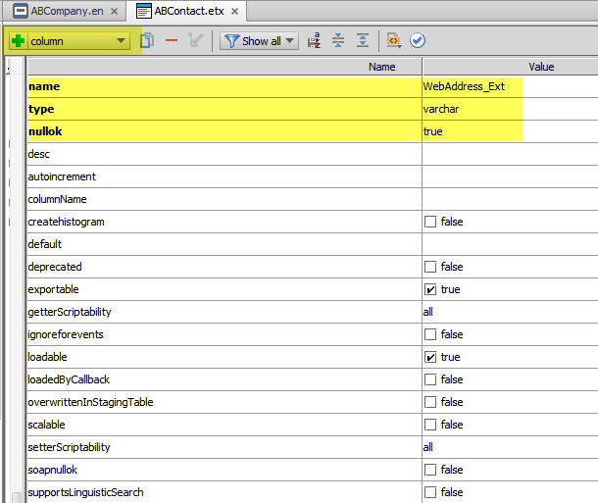

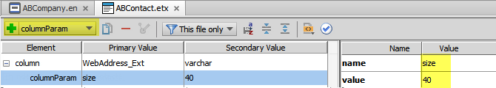

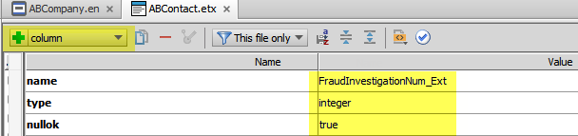

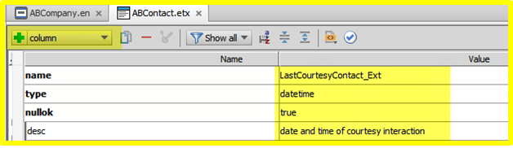

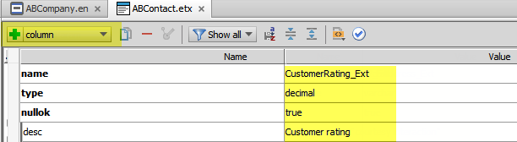

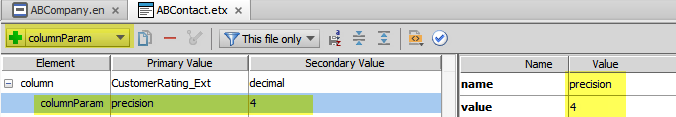

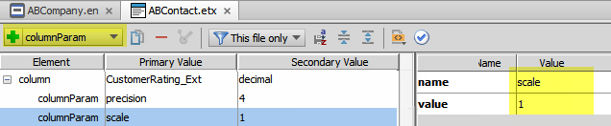

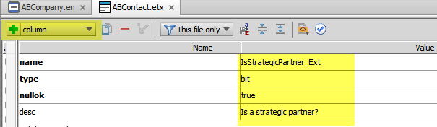

1. Validate your changes in the Entity Editor.
2. View the Xml elements
3. View the Xml and elements in the Entity Editor.

Write it down

Name all the elements associated with CustomerRating_Ext.

|  |
| --- |
| Two columnParam elements: precision and scale |

Optional verification

1. Build the data dictionary from the command window
2. From the bin folder, open a command window.
3. In the command window, enter the command to build the data dictionary.  
   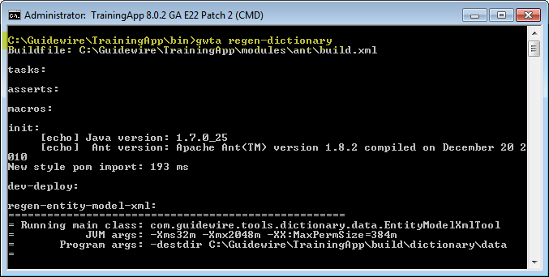
4. Open the data dictionary
5. In Windows Explorer, navigate to the data dictionary.
6. Open the data dictionary using Internet Explorer.
7. View the ABContact entity
8. Verify each new field and associated datatype.

Deployment

1. Deploy your changes
2. From studio, restart the server using Debug 'Server'.
3. If open, review the Messages Make window for compilation errors.
4. Review the Debug console for errors.
5. Verify that the application is running in the Debug console.

|  |  |
| --- | --- |
|  | Stop and ask your instructor to review your completed lab. |